**Hart Publishing is delighted to announce the publication of**

**‘The Law of Misstatements: 50 Years on from *Hedley Byrne v Heller’* edited by Kit Barker, Ross Grantham, Warren Swain**

We are pleased to offer you **20% discount** on the book

To order online with your **20% discount** please click on the link below the title and then click on the ‘pay now’ button on the right hand side of the screen. Once through to the ordering screen type ref: **CV7** in the voucher code field and click ‘apply’

Alternatively, please contact Hart Publishing’s distributor, Macmillan Distribution Limited, by telephone or email (details below) quoting ref: **CV7**

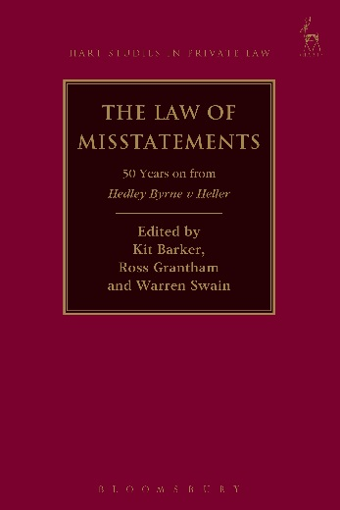**The Law of Misstatements: 50 Years on from *Hedley Byrne v Heller***

*Edited by Kit Barker, Ross Grantham, Warren Swain*

2013 was the 50th anniversary of the House of Lords’ landmark decision in *Hedley Byrne v Heller*. This international collection of essays brings together leading experts from five of the most important jurisdictions in which the case has been received (the United Kingdom, the United States, New Zealand, Canada and Australia) to reappraise its implications from a number of complementary perspectives – historical, theoretical, conceptual, doctrinal and comparative. It explores modern developments in the law of misstatement in each of the jurisdictions; examines the case’s profound effects on the conceptual apparatus of the law of negligence more generally; explores the intersections between misstatement liabilities in contract, tort, equity and under statutory consumer protection provisions and critically assesses the ways in which advisor liabilities have come to be limited and distributed under systems of ‘joint and several’ and ‘proportionate’ liability respectively. Inspired by *Hedley Byrne*, the purpose of the collection is to reflect on the case’s echoes, effects and analogues throughout the private law and to provide a platform for thinking about the ways in which liabilities for misstatement and pure economic loss should be modelled in the modern day.

***Kit Barker*** is Professor of Law, ***Ross Grantham*** is Professor of Commercial Law and ***Warren Swain*** is Associate Professor of Law, all of the TC Beirne School of Law, The University of Queensland.

**BOOK DETAILS**

August 2015   9781849468633 408pp   Hbk   RSP: ~~£65~~

**20% Discount Price: £52**

[**Order Online**](http://www.hartpub.co.uk/books/details.asp?isbn=9781849460033)

If you would like to place an order you can do so through the Hart Publishing website (link below). To receive the discount, please click on the ‘pay now’ button on the right hand side of the screen. Once through to the ordering screen type ref: **CV7** in the voucher code field and click ‘apply’.

[**http://www.hartpub.co.uk/BookDetails.aspx?ISBN=9781849468633**](http://www.hartpub.co.uk/BookDetails.aspx?ISBN=9781849468633)

**Alternatively, please contact Hart Publishing’s Distributor, Macmillan Distribution Limited, by telephone or e-mail and quote reference CV7 when placing your order.**

Macmillan Distribution (MDL), Brunel Road, Houndmills, Basingstoke, RG21 6XS, UK

**UK ORDERS:** Tel: +44 (0)1256 302692    Fax: +44 (0)1256 812521 / 812558      E-mail: [direct@macmillan.co.uk](mailto:direct@macmillan.co.uk)

**EU AND ROW ORDERS:** Tel: +44 (0)1256 329242    Fax: +44 (0)1256 842084    E-mail: [export@macmillan.co.uk](mailto:export@macmillan.co.uk)